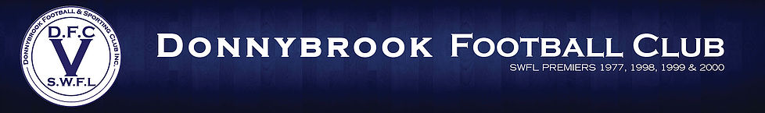
Management Committee Nomination Form

I _____________________________hereby nominate __________________________
for the position of Management Committee Member at the upcoming AGM of the Donnybrook Football Club on the 15th of December 2022, for the 2023 Season.

Nominee _____________________________

Nominator _____________________________

Seconder ______________________________

Nominations for Committee of Management positions must be received by the President by no later than 5.00pm Thursday 1st December 2022.
Nominations to be sent to the President phearman53@bigpond.com

